
CYBERSTER CYBERSECURITY
INTERNSHIP TASK REPORT
Week 2: Network Creation and Ethernet Cable Making
Using Cisco Packet Tracer and T568B Standard
Name | Khawaja Faraz Ahmad
Internship Program | Cyberster Cybersecurity Internship
Task Title | Week 2: Network Creation in Cisco Packet Tracer and Ethernet Cable Making using Standard B (T568B)
Classification | Confidential - For Internal Review Only
Engagement Type | Basic Network Implementation & Physical Cabling Practice

I designed this lab as more than a basic router-switch-PC exercise. The final topology demonstrates routed connectivity between three separate LANs using RIPv2, subnetting, serial WAN links, route verification, and basic documentation suitable for a beginner-level portfolio project.
Date: ____________________

Table of Contents
- 1. Task Objectives
- 2. My Enhanced Network Task
- 3. Network Topology Overview
- 4. IP Addressing Plan
- 5. RIPv2 Routing Configuration
- 6. Verification and Testing
- 7. Ethernet Cable Standard B Table
- 8. Tools Used
- 9. Step-by-Step Cable Making Process
- 10. Challenges Faced and Learning Outcomes
- 11. GitHub and LinkedIn Presentation Plan
- 12. Conclusion

1. Task Objectives
The assigned task had two main objectives. The first objective was to build a working network in Cisco Packet Tracer using devices such as a router, switch, access point, PCs and phones. The second objective was to prepare an Ethernet cable Standard B table and mention the tools used for the cabling activity.
- Build a basic network in Cisco Packet Tracer and confirm end-to-end connectivity.
- Document the addressing scheme, devices and important configuration commands.
- Prepare an Ethernet cable T568B pinout table with wire colors and signal use.
- List the physical and software tools used during the task.

2. My Enhanced Network Task
To show stronger practical skills, I expanded the basic task into a multi-router routed network. Instead of making only one small LAN, I created three LAN sites connected with serial WAN links. I then configured RIP Version 2 so that each router could automatically learn the remote LAN routes. This makes the project more realistic because it shows subnetting, routing, verification and troubleshooting, not only device connection.
- Three separate LANs were created using /29 subnets.
- Three routers were connected using serial links.
- RIP Version 2 was configured on all routers.
- The routing table was checked using show ip route to prove that remote networks were learned dynamically.
- This project can be uploaded to GitHub with screenshots, Packet Tracer file and this report.

3. Network Topology Overview
The topology contains three LAN areas. Each LAN has a router, switch and end devices. The routers are connected through serial WAN links. RIPv2 shares routing information between all routers, which allows PCs in different LANs to communicate with each other.
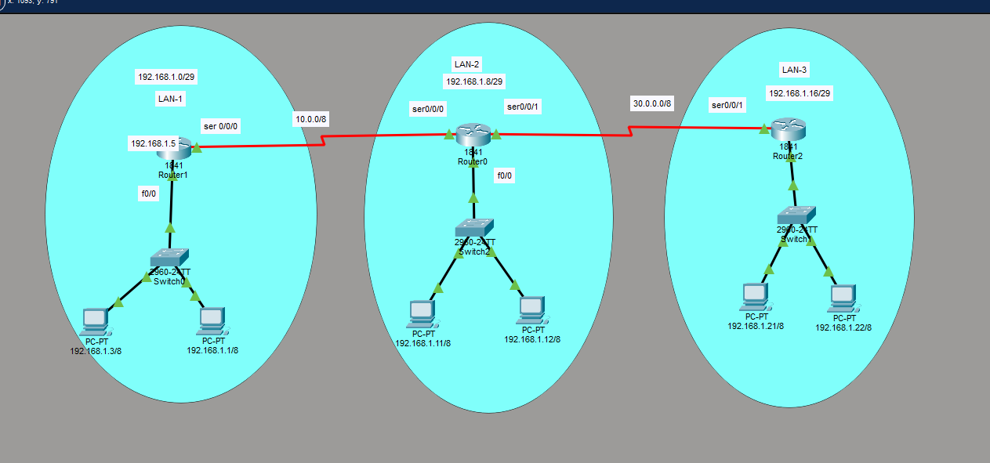
Figure 1: Cisco Packet Tracer topology created for the RIPv2 network lab

Device Summary
Device Type | Quantity | Example Device Names | Purpose
Router | 3 | Router1, Router0, Router2 | Connect LANs and exchange routes through RIPv2
Switch | 3 | Switch0, Switch2, Switch1 | Connect PCs inside each LAN
PC | 6 | Two PCs per LAN | End devices used for testing connectivity
Serial Links | 2 | 10.0.0.0/8 and 30.0.0.0/8 | WAN connectivity between routers

4. IP Addressing Plan
The LAN networks were divided into small /29 subnets. A /29 subnet provides 6 usable host addresses, which is enough for a small lab LAN containing a router interface and a few PCs. The serial links in the current Packet Tracer lab are shown as 10.0.0.0/8 and 30.0.0.0/8. In a real production network, a /30 or /31 subnet would normally be preferred for point-to-point serial links to save IP addresses.
Location | Network | Subnet Mask | Router Interface | Gateway IP | Example Host IPs
LAN-1 | 192.168.1.0/29 | 255.255.255.248 | R1 Fa0/0 | 192.168.1.5 | 192.168.1.1, 192.168.1.3
LAN-2 | 192.168.1.8/29 | 255.255.255.248 | R0 Fa0/0 | 192.168.1.10 | 192.168.1.11, 192.168.1.12
LAN-3 | 192.168.1.16/29 | 255.255.255.248 | R2 Fa0/0 | 192.168.1.18 | 192.168.1.21, 192.168.1.22
WAN-1 | 10.0.0.0/8 | 255.0.0.0 | R1 S0/0/0 - R0 S0/0/0 | N/A | 10.0.0.1, 10.0.0.2
WAN-2 | 30.0.0.0/8 | 255.0.0.0 | R0 S0/0/1 - R2 S0/0/1 | N/A | 30.0.0.1, 30.0.0.2
Note: The gateway IPs are based on the topology screenshots and common lab addressing practice. If the Packet Tracer file uses slightly different interface IPs, the table can be adjusted without changing the overall design.

5. RIPv2 Routing Configuration
RIP Version 2 was selected because it is simple to understand and useful for learning dynamic routing. RIPv2 supports classless routing and works better with subnetted networks compared with RIP Version 1. The no auto-summary command is important because it prevents automatic classful summarization and helps the routers advertise the /29 LAN subnets correctly.

Router1 Configuration
hostname Router1
interface FastEthernet0/0
ip address 192.168.1.5 255.255.255.248
no shutdown
interface Serial0/0/0
ip address 10.0.0.1 255.0.0.0
clock rate 64000
no shutdown
router rip
version 2
no auto-summary
network 10.0.0.0
network 192.168.1.0

Router0 Configuration
hostname Router0
interface FastEthernet0/0
ip address 192.168.1.10 255.255.255.248
no shutdown
interface Serial0/0/0
ip address 10.0.0.2 255.0.0.0
no shutdown
interface Serial0/0/1
ip address 30.0.0.1 255.0.0.0
clock rate 64000
no shutdown
router rip
version 2
no auto-summary
network 10.0.0.0
network 30.0.0.0
network 192.168.1.0

Router2 Configuration
hostname Router2
interface FastEthernet0/0
ip address 192.168.1.18 255.255.255.248
no shutdown
interface Serial0/0/1
ip address 30.0.0.2 255.0.0.0
no shutdown
router rip
version 2
no auto-summary
network 30.0.0.0
network 192.168.1.0

6. Verification and Testing
After configuring the interfaces and RIPv2, the routing table was checked on all routers. The letter R in the routing table means that the route was learned through RIP. The output confirms that each router learned the remote LAN networks from the next router.
Router | Directly Connected Networks | RIP Learned Networks | Result
Router1 | 10.0.0.0/8 and 192.168.1.0/29 | 192.168.1.8/29 and 192.168.1.16/29 via 10.0.0.2 | Remote LAN routes learned successfully
Router0 | 10.0.0.0/8, 30.0.0.0/8 and 192.168.1.8/29 | 192.168.1.0/29 via 10.0.0.1 and 192.168.1.16/29 via 30.0.0.2 | Middle router has routes to both edge LANs
Router2 | 30.0.0.0/8 and 192.168.1.16/29 | 192.168.1.0/29 and 192.168.1.8/29 via 30.0.0.1 | Remote LAN routes learned successfully
Recommended test commands:
- show ip interface brief
- show ip route
- show running-config
- ping <remote_PC_IP>
- tracert <remote_PC_IP> from PC command prompt
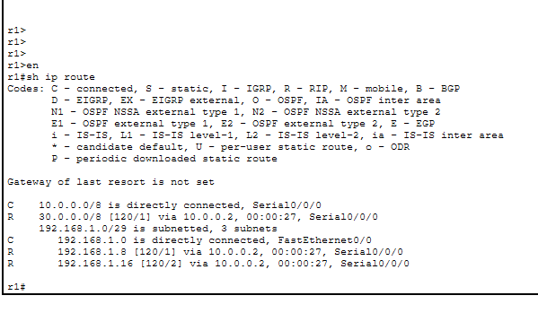
Figure 2: Router1 routing table showing RIPv2 learned routes
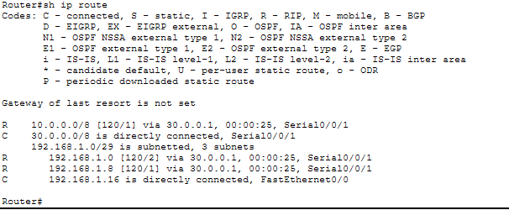
Figure 3: Router0 routing table showing routes from both sides
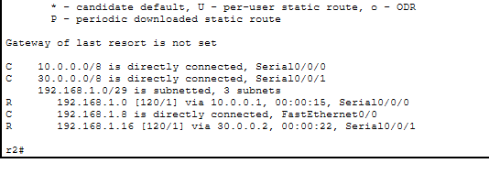
Figure 4: Router2 routing table showing RIPv2 learned routes

7. Ethernet Cable Standard B Table
The Ethernet cable pinout used for this task is T568B, also called Standard B. The same order is used on both ends when making a straight-through cable. This cable is commonly used for connecting a PC to a switch, router to switch, or access point to switch.
Pin | Wire Color (T568B) | Pair | 10/100 Mbps Use | 1000 Mbps Use
1 | White/Orange | Pair 2 | Transmit + | BI_DA +
2 | Orange | Pair 2 | Transmit - | BI_DA -
3 | White/Green | Pair 3 | Receive + | BI_DB +
4 | Blue | Pair 1 | Not used in 10/100 | BI_DC +
5 | White/Blue | Pair 1 | Not used in 10/100 | BI_DC -
6 | Green | Pair 3 | Receive - | BI_DB -
7 | White/Brown | Pair 4 | Not used in 10/100 | BI_DD +
8 | Brown | Pair 4 | Not used in 10/100 | BI_DD -
Straight-through cable rule: both ends should follow T568B. Crossover cable rule: one end follows T568A and the other end follows T568B.

8. Tools Used
The task required both software tools for simulation and physical tools for cable preparation. Listing the tools makes the report stronger because it shows complete understanding of both logical networking and practical cabling.
Tool | Type | Purpose
Cisco Packet Tracer | Software | Network simulation, router configuration and ping testing
Cisco CLI | Software/Command Line | Interface setup, RIPv2 configuration and route verification
UTP Cat5e/Cat6 Cable | Physical | Ethernet cable medium
RJ45 Connectors | Physical | Connectors attached to both ends of cable
Crimping Tool | Physical | Crimps RJ45 connector onto cable
Cable Stripper/Cutter | Physical | Removes jacket and cuts cable cleanly
LAN Cable Tester | Physical | Checks continuity and correct pin order
Labels/Marker | Physical | Cable identification and clean documentation

9. Step-by-Step Cable Making Process
- Measure the required cable length and cut the UTP cable cleanly.
- Strip around one inch of the outer jacket without damaging the internal wires.
- Untwist the wire pairs carefully and arrange them in T568B order.
- Keep the wire ends straight and cut them evenly so they fit properly inside the RJ45 connector.
- Insert the wires into the RJ45 connector while checking that pin 1 starts with White/Orange.
- Crimp the connector using the crimping tool.
- Repeat the same T568B order on the second end for a straight-through cable.
- Test the cable using a LAN cable tester. All eight pins should show the correct sequence.

10. Conclusion
The Week 2 task was completed successfully and improved beyond the basic requirement. The Packet Tracer design shows three different LANs connected through routers and RIPv2 dynamic routing. The routing table screenshots prove that the routers learned remote networks successfully. The Ethernet cable Standard B table and tool list complete the physical networking part of the assignment. Overall, this project is a good beginner-to-intermediate portfolio item for GitHub and LinkedIn because it includes design, configuration, testing and documentation.

